Bathgate Academy Newsletter

Wednesday 8th September, 2021

Head Teacher Update

Thank you everyone for continuing to follow the rules around wearing masks. Remember over your nose, mouth and chin to keep everyone safe. I would like you all to think of ideas about how we can support our whole community and encourage everyone to wear masks. How can we make it less of a moan and more of the right thing to do? Feel free to share your ideas with me at break or lunch. We can all make a positive difference, every single day!

S1 – S3 Pupils Only

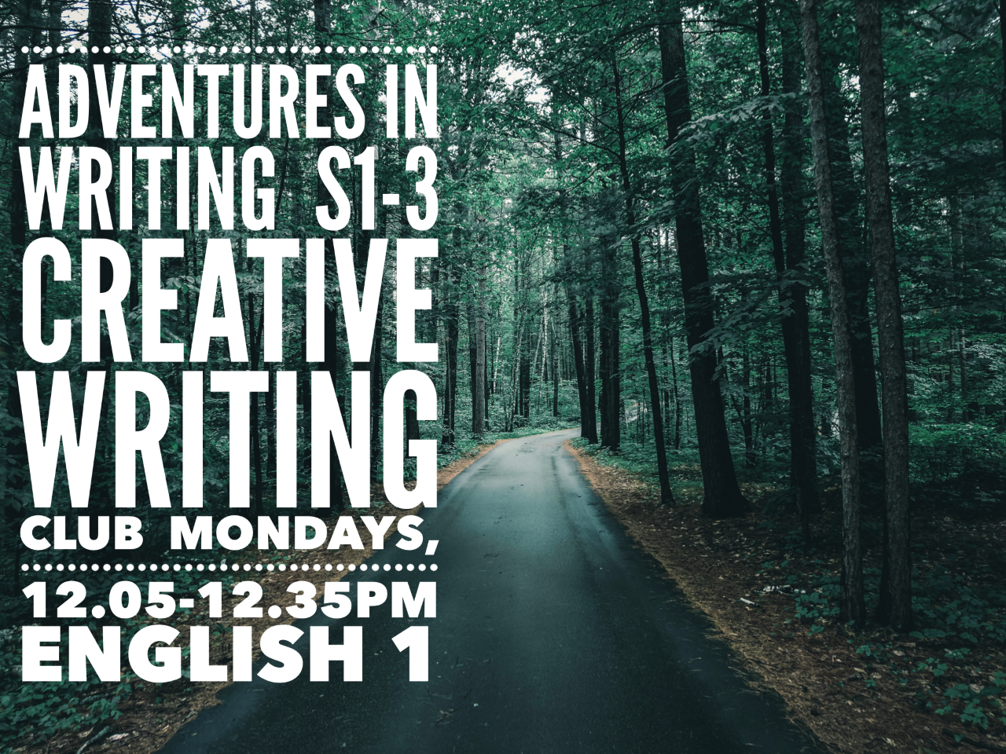

Adventures in Writing, Creative Writing Club for S1-3 pupils, every Monday in English Room 1 - for more information please speak to Mrs Nairn. All welcome!

Excited to announce our new clubs starting 13th September

Creative Writing
Come along to Mrs Nairn’s room, English One, Monday lunch time between 12.05 and 12.35 for some creative writing fun.
Debating Club
Come along to Miss Davie’s room, English Six, Wednesday lunch time between 13.05 and 13.35 for seniors or Thursday lunch time between 12.05 and 12.35 for juniors, to hone your debating skills.

S4 – S6 Pupils Only

All Pupils

