Bathgate Academy Newsletter

Wednesday 9th January 2019

Head Teacher Update

There will be welcome back assemblies on Thursday 10th January. Please come to the Assembly hall at the following times:

S3: 8.30am (register in p1 class first/leave bags/jackets etc)
S4: 9.20am (register in p2 class first/leave bags/jackets etc)
S5/6: 10.10am (register in p3 class first/leave bags/jackets etc)
S2: 11.30 (register in p4 class first/leave bags/jackets etc)
S1: 12.20 (register in p5 class first/leave bags/jackets etc)

S1 – S3 Pupils Only

**Club will resume next Thursday (17th) - Film Club - Harry Potter Film Club for S2 Pupils - in Humanities Rm5 on a Thursday afternoon from 1.25pm. (Miss Gilfillan) - **Club will resume next Thursday (17th)

S4 – S6 Pupils Only

Spanish Supported Study
Supported Study for Spanish will take place on a Monday lunchtime in Miss Bowie's room, this is open to all pupils studying Spanish at National 5 level. Please see Miss Bowie beforehand if there is anything in particular you wish to practice, for example, a family and friends listening.

Maths supported study sessions will be alternating this year to allow more pupils to access it. The sessions will alternate between Thursday after school and Friday after school – your teacher will let you know what day supported study is happening each week.
Mr Easton will support N5 pupils
Dr Lawson will support Higher pupils
S6 pupils are also welcome to come to the department periods 6 & 7 every Wednesday for some extra maths practice (same rooms as above).

"English supported study is on every Monday, from 3:25-4:25pm in English room 5 and 8. All seniors welcome."
There will be supported study for National 5 Art and Design on Mondays from 3.30pm - 5.30pm in Art Rm 1. All Seniors Welcome.
All Pupils

"Maths Club! All pupils are invited to join us at the new Maths Club in Mrs McGregor's Maths Room 7 every Wednesday lunchtime which is run by our S6 Maths Leaders. We will be looking at different activities every week such as tangrams, pentominoes, problem solving riddles. This week is all about Mayan Numbers and problem solving. Feel free to bring your lunch along."

Every Monday there will be a lunchtime drop-in session in Computing Room 1 for pupils who need help logging in to Glow or Show My Homework. If you ​​haven't got the Show My Homework app yet please bring your phone/tablet along and we can talk you through how to set it up

The CDT department are starting a craft club on Tuesday lunchtimes. This is open to all year groups.

There are a range of Music activities running during the week at lunchtimes and after-school. Please check the timetable in the department and this bulletin for days and times.

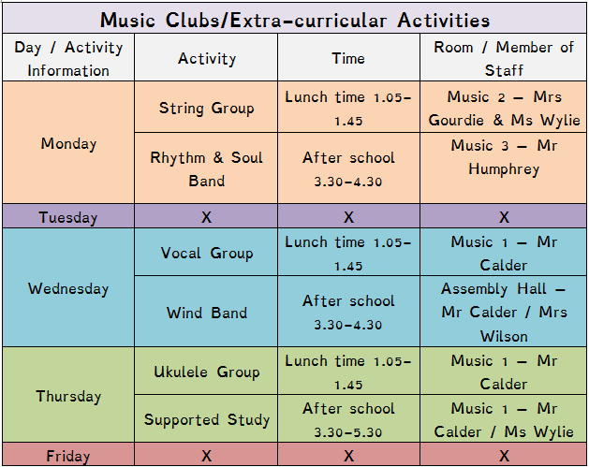

Drama Club is after school every Thursday at 3:30-4:30. Open to all year levels! Drama room 2.

PE Clubs
PE after school and lunchtime clubs are free and available to all pupils S1-6. If you would like to come along please ask a PE teacher for a permission slip (EE2) so you can attend. The clubs on offer are as follows:
