**[](http://www.google.co.uk/imgres?imgurl=http://workoutenginepro.workoutengine.com/static/workoutenginepro/2011/09/idea.jpg&imgrefurl=http://www.missanisah.com/2012/11/eureka-moments.html&h=331&w=143&tbnid=tAgAuKofwsjdZM:&zoom=1&docid=RHJehdMD1lQeoM&ei=EJdaVMIM8JCxBLLTgpAF&tbm=isch&ved=0CD4QMygXMBc&iact=rc&uact=3&dur=444&page=1&start=0&ndsp=33)S2 skills homework – January – Graphs**

If I get stuck I can ask my teacher for help!

1. The Scottish government is keen to cut carbon emissions and has recorded the annual carbon output of Scotland for the past ten years. This information is shown in the table below.

|  |  |
| --- | --- |
| **Year** | **Carbon emissions (tonnes/year)** |
| 2009 | 3 000 000 |
| 2010 | 2 750 000 |
| 2011 | 2 700 000 |
| 2012 | 2 675 000 |
| 2013 | 2 900 000 |
| 2014 | 2 650 000 |
| 2015 | 2 500 000 |
| 2016 | 2 200 000 |
| 2017 | 2 150 000 |
| 2018 | 2 100 000 |

1. Plot a **bar graph** of these results.
2. In which year did carbon emissions fail to decrease?
3. Which year recorded the biggest drop in carbon emissions from the previous year?
4. Using the data from 2016, 2017 and 2018 predict what the carbon emissions for 2019 will be.
5. Scientists have predicted how the world’s fossil fuel reserves will change over future years. This information has been plotted on the graph below.

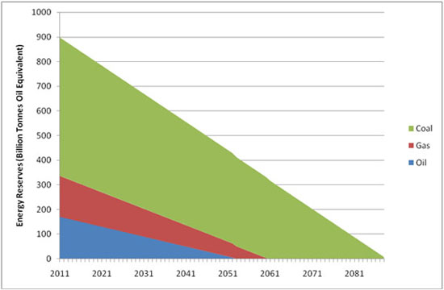

1. In what year will **coal** reserves reach **half** of their 2011 value?
2. When will oil reserves run out?
3. How many billions of tonnes of Gas will remain by 2047?

3 Pupils are conducting an investigation into the effect acid rain has on buildings. They react 1M of Sulphuric acid with marble chips and measure the **total volume of gas** produced every **minute**. Their results are shown in the table below.

|  |  |
| --- | --- |
| Time (mins) | Total volume of gas collected (cm3) |
| 1 | 21 |
| 2 | 42 |
| 3 | 58 |
| 4 | 66 |
| 5 | 71 |
| 6 | 71 |
| 7 | 71 |

1. Plot **a line graph** of the results
2. At what time did the reaction stop?
3. What was the total volume of gas produced after 4.5 minutes?