**2 Proteins**

**(a) Proteomics**

At one time the genome was only considered in terms of the chromosomal DNA. However increased knowledge and understanding of how genes interact, has expanded the term genome to include all of the genetic material in an organism - chromosomal DNA, the extra-chromosomal (mitochondrial, chloroplast or plasmid) DNA and all forms of RNA.

What is meant by the term proteome?

Proteomics is the study of the proteome. Its analysis is far more complex than analysis of the genome which is carried out with DNA sequencing and microarray technology.

DNA sequencing Microarray technology

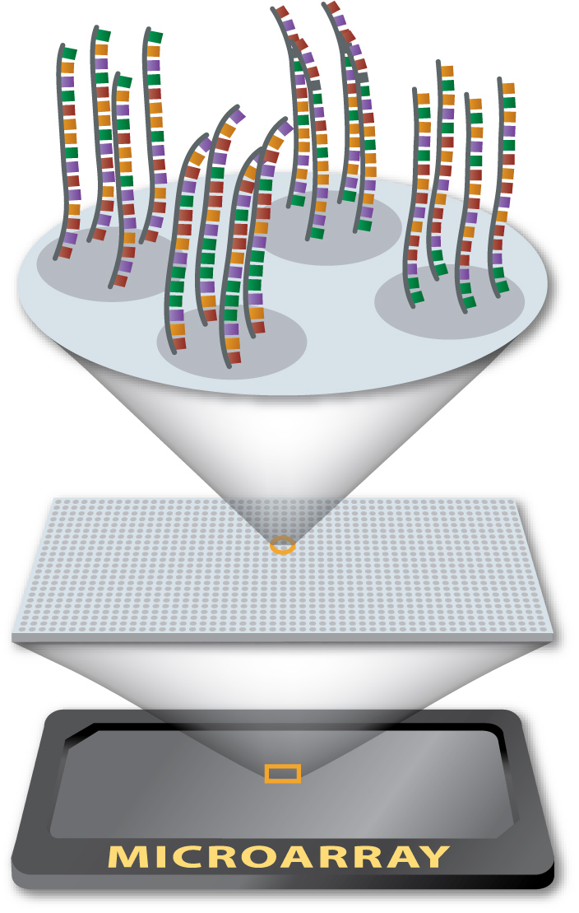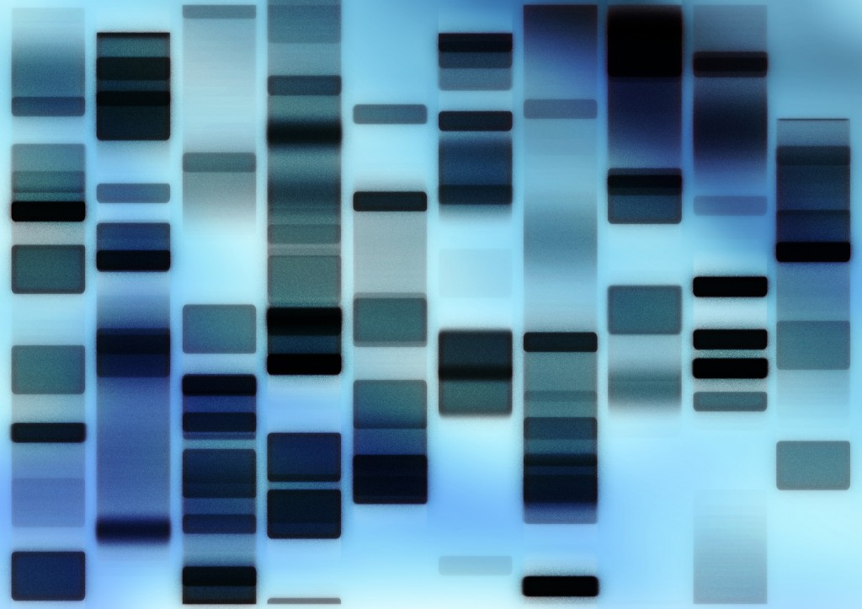

The proteome is larger than the genome due to RNA splicing and post-translational modification.

RNA splicing

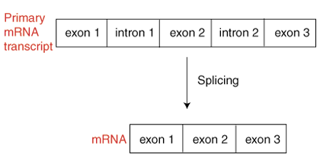

Post-translational modification

After the translation of the mRNA code by the ribosomes the protein can be modified at various locations in the cell. These are -

1

2

3

The modifications fall into 2 main groups-

Addition of chemical groups

Covalent modification

**(b) Protein Structure, binding and conformational change**

Structure and Function

**Structure**

**Function**

***Determines***

***Determines***

The distinguishing feature of protein molecules is their folded nature and their ability to bind tightly and specifically to other molecules. Binding causes a conformational change in the protein which may result in an altered function which may be reversible. Proteins may have one or more stable conformations depending on binding.

Amino acid structure determines protein structure

|  |  |  |
| --- | --- | --- |
| Proteins are polymers of amino acid monomers.  What type of bond links amino acids?  What is meant by the term “primary sequence”?  Basic amino acid structure    A condensation reaction joins two amino acids together to form a peptide bond and removes water.      + H2O  The chain is extended by continuing to add onto the ends. Since each amino acid has both amine and acid groups there is always an amine end to the chain and an acid end to the chain. These are called the N-terminus and C-terminus. |  |  |

What does the R group (also called the side chain) determine?

The R groups are often grouped according to their main interactions.

* Polar groups
* Non-polar groups
* Acidic
* Basic

|  |  |  |  |  |
| --- | --- | --- | --- | --- |
| Group | Polar | Non-polar | Acidic | Basic |
| Interaction with water |  |  |  |  |
| Key R group |  |  |  |  |
| Examples |  |  |  |  |

You are not expected to know all the amino acids, but you must be able to recognise the classes and it would be worth having one example of each.

|  |  |  |
| --- | --- | --- |
| Name | Structure / R group | Notes |
| Cysteine  Cys (C) |  | Example of **polar** group which provides an essential part of the protein structure. The di-sulphide bridge is a covalent link that can join sections of chain together, or link separate chains to each other. |
| Phenylalanine  Phe (F) |  | Good example of a hydrophobic R group. Any aromatic or long chain will be **non-polar** and so will move to an internal section of the protein. Phenylalanine is also linked to phenylketonuria (PKU) an inborn error of metabolism. |
| Glutamate  Glu (E) |  | A good example of an **acidic** R group. Will drive the same associations as the positive groups. |
| Arginine  Arg (R) |  | Good example of a **basic** R group. This will allow ionic associations between sections / chains / additional groups. |

Primary Structure

The primary sequence is formed when

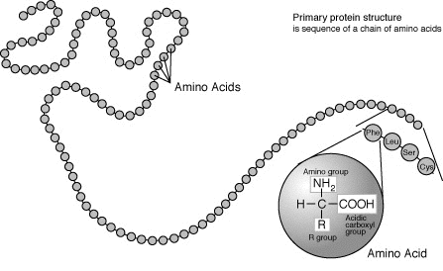

the amino acids link together with

covalent __________ bonds.

The final protein structure is determined

by this initial sequence and the protein

starts to fold driven by the interactions

between the different residues in the chain.

Secondary Structure

Once the main polypeptide chain has formed, they fold into characteristic shapes.

These shapes are stabilised by weak ___________ bonds along the backbone of the protein strand.

There are two main secondary structures –

Alpha Helix

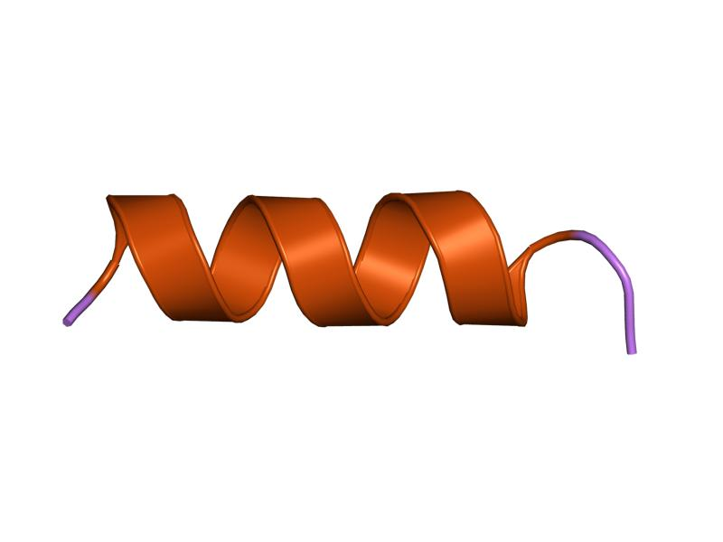

Beta pleated sheet

The chain is arranged in rows, again stabilised with hydrogen bonding between the chain.

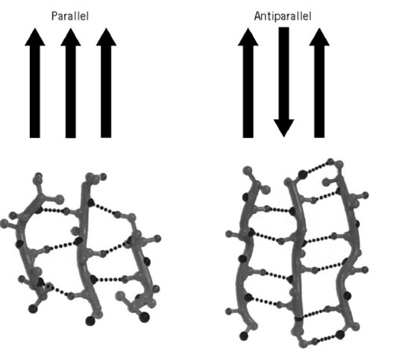

Tertiary Structure

CH2

CH2

S

S

**Disulphide bridge** between two Cys residues (strong covalent)

**Hydrogen bonding** stabilises folds

**Hydrophobic interactions**

Non-polar residues pack together away from water

**Ionics –** between charged residues

**+**

**-**

Once the secondary structures have formed, the final folded polypeptide begins to take a 3D shape.

The final folding is produced by all of the interactions between the R groups of amino acids.

* Disulphide bridges Strong covalent bonds that

link sulphur atoms of adjacent cysteine amino acids.

* Hydrophobic Interactions Occur between non-polar R groups along the length of the polypeptide causing them to face the centre of the protein molecule.
* Ionic bonds Charge dependent attraction occurring between oppositely charged polar R groups, eg between the amino acids arginine and aspartic acid.
* Van der Waals Interactions Weak intermolecular force between adjacent atoms.

Quaternary Structure (proteins with more than one chain)

These proteins are formed from two or more polypeptide chains. It is the intermolecular bonding that holds the structures together.

Prosthetic groups

Prosthetic groups give proteins added function. Eg.haemoglobin.

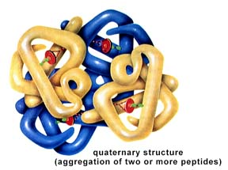

Summary

|  |  |  |
| --- | --- | --- |
| Level of structure | Description | Type of bonds |
| Primary |  |  |
| Secondary |  |  |
| Tertiary |  |  |
| Quaternary |  |  |

Protein shape with temperature and pH

|  |  |
| --- | --- |
| Any factor that changes the interactions of the R groups will change the shape of the protein. |  |

The fluid mosaic model

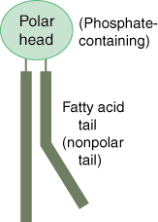

The phospholipid bilayer is composed of phospholipids and proteins.

The phospholipid is the basis of the system. One end is strongly

hydrophobic and the other is hydrophilic. A glycerol molecule forms

three ester links, one with a phosphate group and two with fatty acids.

The phosphate group is highly charged and so hydrophilic.

The fatty acids are non-polar and so hydrophobic.

The first stable structure to form from these molecules is a sphere, where the hydrophilic heads are all facing out and the hydrophobic tails all pack into the centre. This is called a micelle and has an important role in transporting substances around the blood system that are not water soluble. Continue adding molecules and you end up with a bilayer enclosing a hydrophilic area = the basis of a membrane.

Hydrophilic R groups predominate at the surface of a soluble protein found in the cytoplasm.

Hydrophobic R groups cluster at the centre to form a globular (folded) structure.

The mosaic part of the model comes from the arrangement of different proteins in the membrane. The R groups play a role in determining the distribution of the proteins.

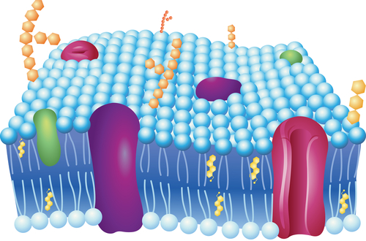

What holds integral proteins within the phospholipid bilayer?

Transmembrane proteins may be -

Peripheral proteins have fewer hydrophobic R groups interacting with the phospholipids.

Binding to ligands

What is a ligand?

DNA as a ligand

DNA binds to a number of proteins.

Histone binding in Eukaryotes

Transcription factors

Effect on protein of the ligand binding

As a ligand binds to a protein binding site or a substrate binds to an enzymes active site, the conformation of the enzyme changes. This change in conformation causes a functional change in the protein.

Induced fit model of enzyme action

In enzymes, specificity between the active site and substrate is related to induced fit.

When the correct substrate starts to bind, a temporary change in shape of the active site occurs increasing the binding and interaction with the substrate.

The chemical environment produced lowers the activation energy required for the reaction.

Once catalysis takes place, the original enzyme conformation is resumed and products are released from the active site.

Activation Energy

Enzymes change the potential energy pathway of reactions, this creates a lower activation energy, so allowing the reaction to occur at biological temperatures.

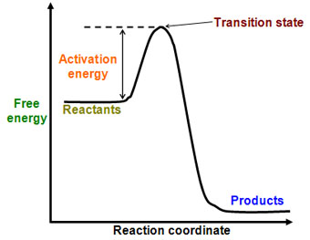

Enzyme Kinetics

Enzyme kinetic curves can give a lot of information about the relationship between the enzyme and its substrate.

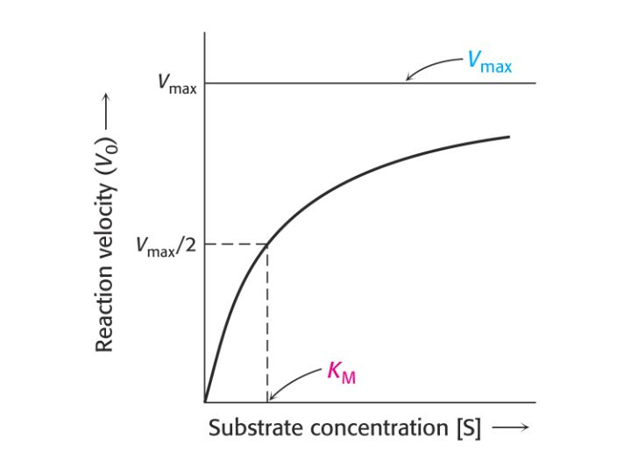

|  |  |
| --- | --- |
|  | Vmax is the maximum velocity of the enzyme activity. It gives a measure of the rate at which the enzyme can catalyse the reaction under these conditions.  Km is the michaelis constant, the substrate concentration that will give you ½ Vmax. It is a measure of the enzyme affinity for its substrate. i.e. high affinity, low Km and vice versa |

To avoid problems with reversible reactions, end point inhibition or just slowing as concentrations get lower the initial velocity (Vo) is taken. Vo is the rate at which the first 10% of the substrate is used, it can be taken from graphs using the tangent of the initial line.

Allosteric enzymes

Allosteric enzymes change form when modulators (regulatory ions) bind at a secondary binding site. The conformation of the enzyme changes and this alters the affinity of the active site for the substrate.

A positive modulator that locks it into the active form is called an activator. A modulator that locks it into an inactive form is an inhibitor.

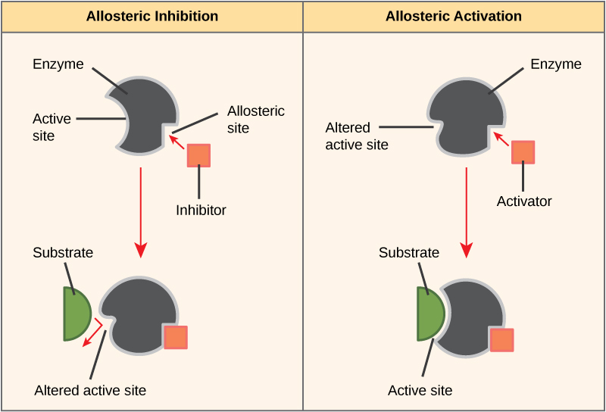

Cooperation in protein groups

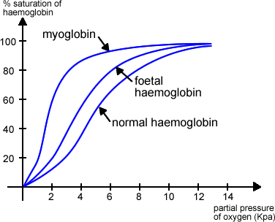

Some proteins with quaternary structure show cooperation, where changes in binding at one subunit alters the affinity of the remaining groups.

Haemoglobin is a good example - there are four chains with a haem group in each that can bind to oxygen.

The first oxygen that associates causes the other chains to become more likely to bind to oxygen. This cooperative effect creates a sigmoid association / dissociation curve.

Reversible binding of phosphate and control of conformation

Phosphate is a highly charged group that is often used to create a reversible conformational change in proteins. The charge will alter the R group interactions within the protein and as it is small and easy to move it makes it a useful group to use as a reversible change. It is a common post-translational modification that can be used to activate or inhibit proteins action.

Proteins involved in phosphate movement -

* Kinase
* Phosphatase
* ATPase

Conformational change with phosphate – Actin and Myosin

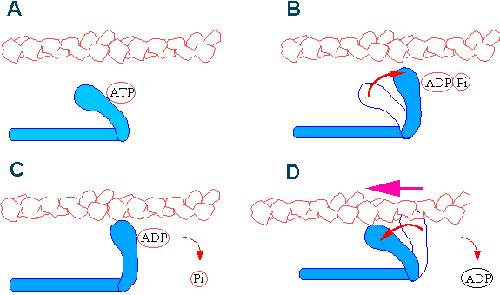

Myosin has heads that act as cross bridges as they bind to actin. When ATP binds to myosin, the myosin head detaches from actin, swings forwards and rebinds. The rebinding releases the ADP and a phosphate ion drags the myosin along the actin filament.

**c) Membrane proteins**

The phospholipid bilayer is a barrier to ions and most uncharged polar molecules as they will not cross into the hydrophobic core of the bilayer.

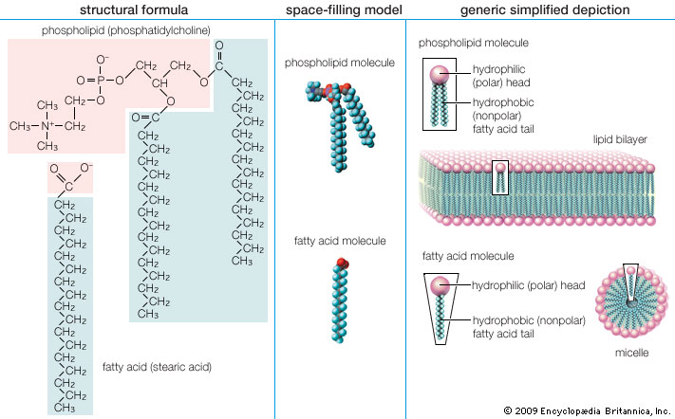

Uses of transmembrane proteins

Movement across the membrane can be controlled in many ways.

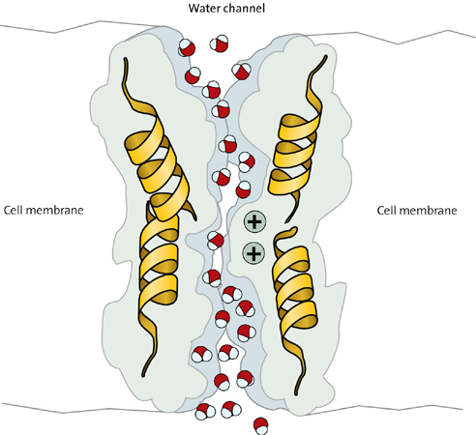

An aquaporin channel protein

Small molecules that can only move slowly by passive diffusion can

be speeded through the membrane using transmembrane channel proteins that are specifically shaped to that molecule.

This is called facilitated diffusion and is a passive process.

Gated channels

Some channel proteins are gated and change conformation to allow or prevent diffusion.

They are always open channels and can be controlled by signal molecules.

Ligand-gated channels -

Voltage-gated channels -



Facilitated transport (passive) is found where a transmembrane protein provides a channel for transport, but does not require energy to move the substance. For example, glucose uptake into red blood cells is mediated by a transmembrane protein called glucose permease. This gives the glucose a hydrophilic pathway through the membrane, increasing the rate of transport across the membrane by around 50,000 times compared to simple diffusion.

Active transport requires energy to move substances against the concentration gradient. Where transmembrane transporters are used phosphate is often used as the group to drive conformational change, so ATPase action is used as part of the system. eg Na/K ATPase pump.

Signal transduction

A basic process in molecular cell biology involving the conversion of a signal from outside the cell

to a functional change within the cell.

Often signal molecules (mainly hydrophilic ones) are not actually moved into the cell, instead the response is produced using a signal transduction pathway. This uses receptor proteins on the surface that are altered by the binding of the signal (ligand) that then sets off reactions within the cell.

Extracellular chemical signal Intracellular response

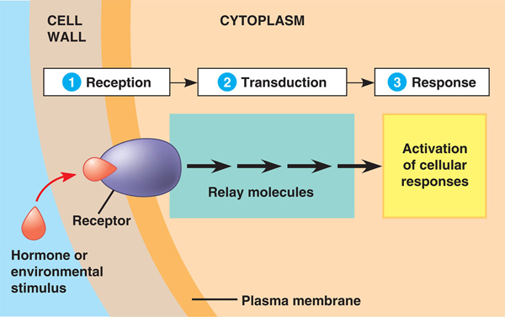

Signal transduction may result in the activation of an enzyme or G protein, a change in uptake or secretion of molecules, rearrangement of the cytoskeleton or activation of proteins that regulate gene transcription.

Ion transport pumps and generation of ion gradients

Na/K ATPase pump

The sodium potassium pump transports ions against a steep concentration gradient using energy directly from ATP.

Key features of the sodium-potassium pump.

1

2

3

Mechanism

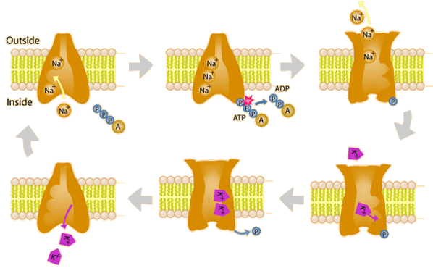

**1 2 3**

**6 5 4**

1. The protein is open to the inside of the cell with binding sites for 3 Sodium ions available.
2. ATPase action removes P from ATP (phosphorylation) and binds to the protein.
3. The conformation of the protein changes, opening the protein to the outside of the cell and changes the binding sites so the sodium ions are released and 2 potassium sites form.
4. 2 potassium ions bind to the protein.
5. The Phosphate is released from the protein making it change back to its original conformation.
6. The potassium binding sites are lost, so the potassium is released into the cell and the steps are repeated.

Functions of the Na/K pump

1

2

3

4

The maintenance of ion gradients by K/Na ATPase accounts for significant part of basal metabolic rate (up to 25% in humans)

Ion channels and nerve transmission

Nerve cells (neurones) maintain a high level of ions in the cytoplasm and so have a potential difference you can measure from inside to outside the cell. This is called the resting potential in the cell.

What is a nerve transmission?

What triggers the start of the wave?

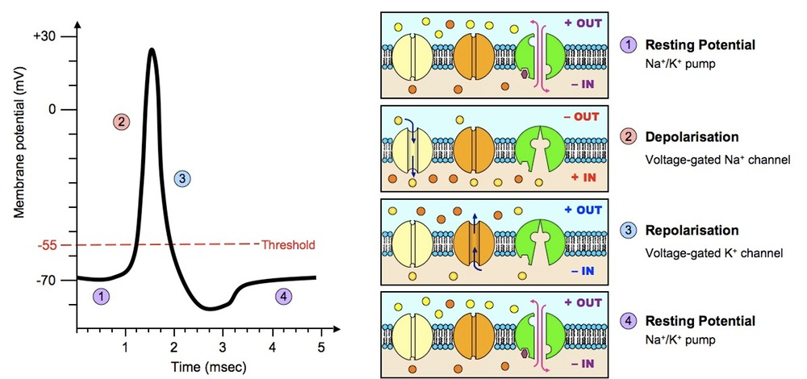

**(d) Detecting and amplifying an environmental stimulus**

Photoreceptor protein systems are found in archaea, plants and animals.

1 Archaea

Bacteriorhodopsin molecules generate potential differences by absorbing light to pump proteins across the membrane.

|  |  |
| --- | --- |
| *Revision from Higher*  3  H+  1  H+  H+  2  H+  H+  H+  H+  H+  H+ | 1. Hydrogen ions (protons) are transported against the concentration gradient to create a potential difference across the membrane. 2. The flow of hydrogen ions from high to low concentration rotates a section of ATP synthase 3. ATP is generated from ADP and Pi from another section of the ATP synthase protein |

2 Plants

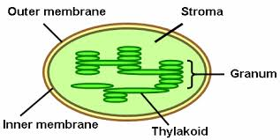

In archaea and plants, the resulting diffusion of hydrogen ions back across the membrane drives ATP synthase.

ATP synthase

ADP + Pi ATP

3 Animals

Photoreception in animals occurs in the human retina. The human retina contains two types of photoreceptors, rods and cones.

Cone cells are used for colour vision and function in bright light. They contain different forms of a membrane protein called opsin that are sensitive to different wavelengths of light ranging through red, green, blue or UV.

Rod cells work over a wider range of wavelengths in weaker light, so involve amplification of the light signal. The outer segment of rod cell membrane disks contain rhodopsin.

The cells contain synaptic vesicles containing neural transmitters, adapted to a much lower

-

resting potential (-10mV) than most neurones (-60 to -90mV). In the dark they are constantly secreting neurotransmitters and stimulating the neurons linked further back in the retina.

Light hitting the rod cell causes hyperpolarisation (more negative) charge by triggering the

closure of Na+ channels in the membrane, as more light is absorbed more channels close and

so less and less neurotransmitter is released.

Creating the signal

The photoreceptor in rods is called rhodopsin which is made up of a transmembrane protein - opsin Opsin is bound to a light absorbing pigment 11-*cis*-retinal. This absorbs in the visible range (400-600nm) and drives isomerisation to 11-*trans*-retinal.

When the membrane protein opsin binds to *trans*-retinal it becomes activated opsin and signal transduction causes Na+ channels to open. The signal transduction involves removing cGMP, a molecule that is normally at very high levels due to active phosphorylation enzymes in the membrane. The Na+ channels are allosteric channels, held open by binding to 3 cGMP molecules. Any drop in the cGMP level causes a rapid drop in the number of open channels. To make the system more sensitive the whole signal transduction is set up as a cascade.

One activated opsin 🡪 activates around 500 activated transducins (a G protein) 🡪 cGMP phosphodiesterase 🡪 converts 3’,5’-cGMP to 5’GMP 🡪 lose allosteric modulator 🡪 closed Na+ channel.

To allow the system to reset the activated opsin readily dissociates, and an enzyme converts the *trans*-retinal back to *cis*-retinal.

**e) Communication with Multicellular Organisms**

(i) Coordination

Coordination of cell signals and responses within a multicellular organism is important in physiological homeostasis and in dealing with physiological stress. i.e. coordination of physiological mechanisms is key to maintaining levels within tolerable limits and thus ensuring survival.

Describe communication within animals.

Regardless of the method of communication, a general pattern of communication is followed.

Signal Receptor Response

Extracellular signalling molecules

Receptors

Responses (Tissue-specific responses to the same signal) Different cell types produce specific signals which can only be detected and responded to by cells with the corresponding specific receptor. Therefore, different cell types can show different responses to the same signal.

(ii) Hydrophobic signals and control of transcription

Hydrophobic signals detected in the nucleus

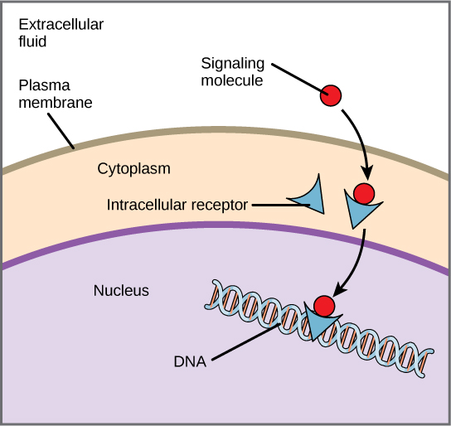

Example 1 Role of Thyroid hormone thyroxine on transcription of the gene for Na/K-ATPase in changing metabolic rate.

In the absence of thyroxine, a thyroid hormone receptor protein binds to DNA and inhibits transcription of the gene for Na/K-ATPase. When thyroxine is present, it binds to the intracellular thyroid hormone receptor protein. This causes a conformational change that prevents inhibition of transcription. Thus, transcription of the gene for Na/K-ATPase occurs resulting in an increased metabolic rate.

Example 2 Steroid hormones bind to receptor proteins which act as transcription factors.

The receptor proteins for steroid hormones (eg. sex hormones such as testosterone) are known as transcription factors. These factors allow transcription of DNA by binding to specific receptors for gene regulatory sequences of DNA.

Hydrophilic signalling molecules

When a ligand binds to a transmembrane protein, a conformational change occurs. The signal molecule does not enter the cell but passes on a signal to be transduced into the cell via the membrane protein. Transduced signals often involve a subsequent cascade of amplification, second messengers, internal regulators and tissue-specific effectors. Examples include G-proteins or phosphorylation by kinase enzymes.

Binding of the peptide hormone insulin

When insulin binds to its receptor it triggers recruitment of a glucose transporter called GLUT4 to the cell membranes of fat and muscle cells. This transporter improves glucose uptake to cells.

Type 1 diabetes

Type 2 diabetes

Binding of the peptide hormone ADH

ADH receptors are located in the collecting duct of kidney nephrons. Upon binding, ADH triggers recruitment of the channel protein aquaporin 2 (AQP2). Aquaporins allow increased movement of water molecules by osmosis across membranes, allowing improved osmoregulation.

Diabetes insipidus

**(f) Protein control of cell division**

Cytoskeleton

|  |  |
| --- | --- |
| The cytoskeleton gives mechanical support and shape to cells. It consists of different types of  proteins extending throughout the cytoplasm.  What are microtubules?  Where are microtubules located?  25nm  -tubulin  -tubulin | Composition of cytoskeleton |

The process of cell division involves remodelling of the cell’s cytoskeleton. It involves,

New organelles and cell constituents being produced and distributed

Organelles currently in place need to be moved to new positions for daughter cells.

Chromosomes need to be moved in a precise order.

The cell cytoplasm and whole cell needs to split in two.

The cell cycle

The cell cycle regulates the growth and replacement of genetically identical cells throughout the life of an organism.

The cell cycle can be divided into two phases, Interphase and Mitosis.

Interphase

Interphase is split into three distinct phases.

Gap 1 phase (G1)

Synthesis (S)

Gap 2 phase (G2)

Mitosis is split into 4 phases.

|  |  |  |
| --- | --- | --- |
| Prophase | Nuclear membrane  cytoplasm  chromatids |  |
| Metaphase | pole |  |
| Anaphase | Separated chromatid |  |
| Telophase | Chromosomes uncoiling  Nuclear membrane reforming |  |

After mitosis the cytoplasm must divide to form two daughter cells.

What is this called?

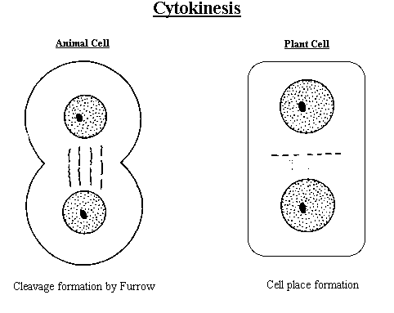

In animal cells, In plant cells,

a cleavage furrow forms  a cell plate is formed

which pinches the cell as the new cells wall forms.

into two.

Mitosis can be observed under a microscope. The percentage of cells undergoing mitosis is called the mitotic index.

How is it calculated?

If cell division and progression through the cell cycle is not controlled it can be damaging.

What may result from an uncontrolled reduction in the rate of the cell cycle?

What may result from an uncontrolled increase in the rate of the cell cycle?

It is essential that the cell cycle progresses at the right time and in the right way to ensure normal development.

Control of the cell cycle

Progression through the cell cycle is regulated by checkpoints G1, G2 and metaphase.

Checkpoints are critical points where “stop” and “go ahead” signals regulate the cycle.

G1 checkpoint

As the cell size increases during G1, cyclin proteins accumulate and combine with kinases to

form regulatory protein molecules known as cyclin-dependent kinases (Cdks).

Cdks cause the phosphorylation of proteins that stimulate the cell cycle.

If a sufficient threshold of phosphorylation is reached the cell cycle moves on to the next stage.

If an insufficient threshold is reached, the cell is held at a checkpoint.

Activating a “go ahead” at the G1 checkpoint

*A particularly important phosphorylation is of Retinoblastoma (Rb). Rb is a transcription factor inhibitor.*

*Phosphorylation of this means it can no longer bind to the DNA sites it was bound to, and so less inhibition passes the threshold.*

Increasing cell size accumulates G1 cyclin proteins.

combine

Kinases

Cdks = Cyclin dependent kinases

Phosphorylation of cell cycle proteins

Phosphorylation threshold

Reached

Not reached

Pass G1 checkpoint proceed to S

G2 checkpoint

This occurs at the end of G2 to check the success of DNA replication.

Any fault at this point can stop cell development until repairs are carried out.

What happens if damage is too great?

M Checkpoint

A further checkpoint at M is the last chance for the cell to ensure that chromosomes are aligned

on the spindle before anaphase occurs.

Control of apoptosis

Cells can enter apoptosis due to -

Signals inside the cell (intracellular)

Signals from outside the cell (extracellular).

Signals trigger DNAase and proteinases (caspases)

Brief overview of paths shown below.

Intracellular Pathway

Extracellular Pathway

Cellular stress

*DNA damage*

Death ligand

caspase 8 (active)

Activated by DNA damage

p53

Death receptor

Cytochrome c released from mitochondria

pro-caspase 8 (inactive)

Activated Bax

Apoptosome

(cytochrome C + Apaf1)

Apaf1

Active Caspase 9

Inactive caspase 3

Active caspase 3

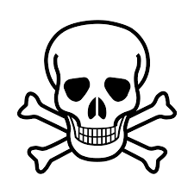

Further cascade reactions

APOPTOSIS

The death ligands can be toxins or other chemicals that do damage, but also can be produced by lymphocytes to trigger death in infected, damaged or endangered cells.