**1 Laboratory Techniques for Biologists**

1. **Health and Safety**

Before any activity is carried out in the laboratory the protocol should first be considered in terms

of hazards and risk.

What is a hazard?

The likelihood of a hazard having an impact is the risk. Risk should be considered in terms of;

1. How much harm would exposure to the hazard cause.
2. How much exposure would create impact.

In science labs there will be multiple hazards. Describe some -

Methods of control

Once a hazard has been identified and is considered to have a risk, you should put in place controls. These may be physical or biological.

Eliminate - If you can remove the hazard from the procedure then this should be done. It may be that a particular step can be removed from a protocol.

Substitute - Some hazards are very particular to the chemical or organism involved, and there may be alternatives that do not produce the same level of risk.

Isolate - If you cannot remove the hazard or substitute it out, isolating particular hazards is a powerful control mechanism e.g. use of fume cupboards, only allowing access to a small group of people.

Administrative - When working with hazards one of the most powerful mechanisms is to put in place particular ways of working (standard operating procedures-SOPs that are designed to reduce risk.

Personal Protective Equipment (PPE) - This can include dust masks, air filters, suits, gloves, aprons, and footwear. This is normally considered as a ‘last line of defence’ and normally will be used with isolation and administrative controls as well.

What would Biological control involve?

A risk assessment is a full consideration of all the hazards and the potential risk with controls that can be taken to minimise the risk.

**(b) Liquids and solutions**

Apparatus when working with liquids should be considered in terms of; accuracy, precision and the volumes involved.

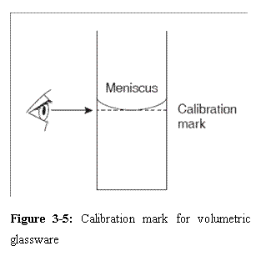

Measuring cylinders

Standard flasks

Pipettes

Burettes

Autopipettors

Syringes

Dilutions

Solutions are diluted for many reasons. Depending on what the solution is to be used for the method of dilution can vary.

|  |  |
| --- | --- |
| Linear dilution  Used if you need a sample over a reasonably small range. Taking a proportion from the stock and diluting using the solvent (normally distilled water) to bring up to volume. | Serial dilution  Where dilution is needed across a wide range a serial dilution produces samples which differ from the next by an order of magnitude each time.  1ml  1ml  1ml  e.g.  + 9ml  water  + 9ml  water  + 9ml  water  Stock solution  1 in 10  0.1  10-1  1 in 1000  0.001  10-3  1 in 100  0.01  10-2 |

Graphing with log scales

Serial dilutions give you a scale that can be represented in different ways. Often the numbers are given with no indication that the scale is a log scale and you must be very careful when reading off the values. *eg. from advanced higher paper 2010, section B Q1*

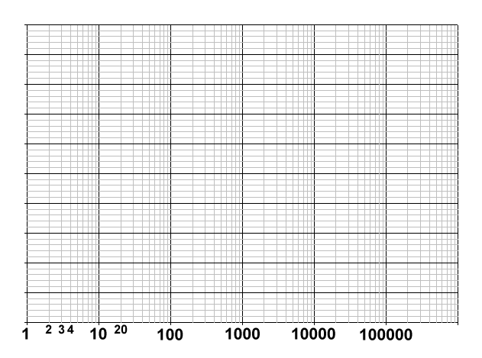

Other graphs use a particular paper that gives a clearer indication of the data, but still must be read very carefully. Paper can be semi-log, where either the x or y axis is a log scale, or log-log where both are log scales. The example shown is semi-log, log on the x-axis.

pH is a continuous scale indicating the hydrogen ion concentration in a solution.

What is used to measure pH?

Buffers are frequently used in Biology experiments. What are buffers and why are they used?

What is a colorimeter?

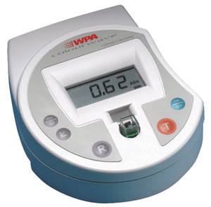

**(c) Separation techniques**

Biological systems often involve mixtures - these could be of cells, DNA fragments, proteins and other compounds. To analyse systems properly you must be able to separate the component parts and to do this you need something that can differentiate between the parts.

Centrifugation

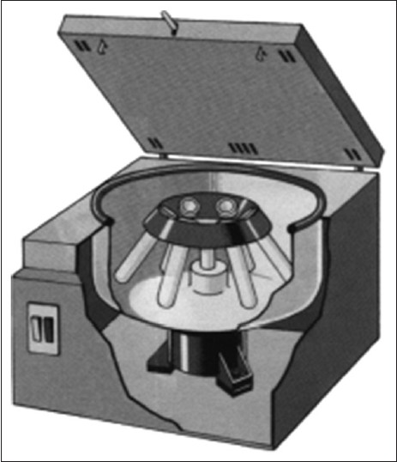

Solubility Partition

If a substance has different solubility in two solvents

you can set up a partition. Basically the two solvents

are mixed with the substance, allowed to settle and

the layer with the substance pulled off.

Chromatography

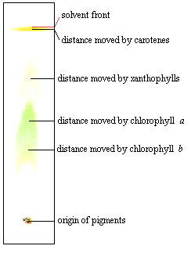

i) Paper

Uses paper as the stationary phase and a solvent as the mobile phase. The

mobile phase could be just water, or a more complex mix of solvents to help

distinguish between the bands. The solvent moves up and compounds are

dropped out of solution at particular points. The Rf value is the fraction given

as = distance of band divided by the distance to solvent front.

ii) Thin Layer chromatography (TLC)

Uses a different stationary phase, commonly cellulose or silica gel spread in a thin

layer on top of glass, plastic or metal.

iii) Affinity chromatography

Uses a different approach to paper or TLC chromatography. This time the stationary phase is

chosen to have the ability to bind to the required substance. This could be through chemical

bonding, charge or even antibody associations. The mixture is poured through (if gel) or over the

stationary phase and the rest discarded. The entrapped substance is then removed from the

stationary phases using a second process, called elution.

Protein electrophoresis

This uses current flowing through buffer to separate proteins.

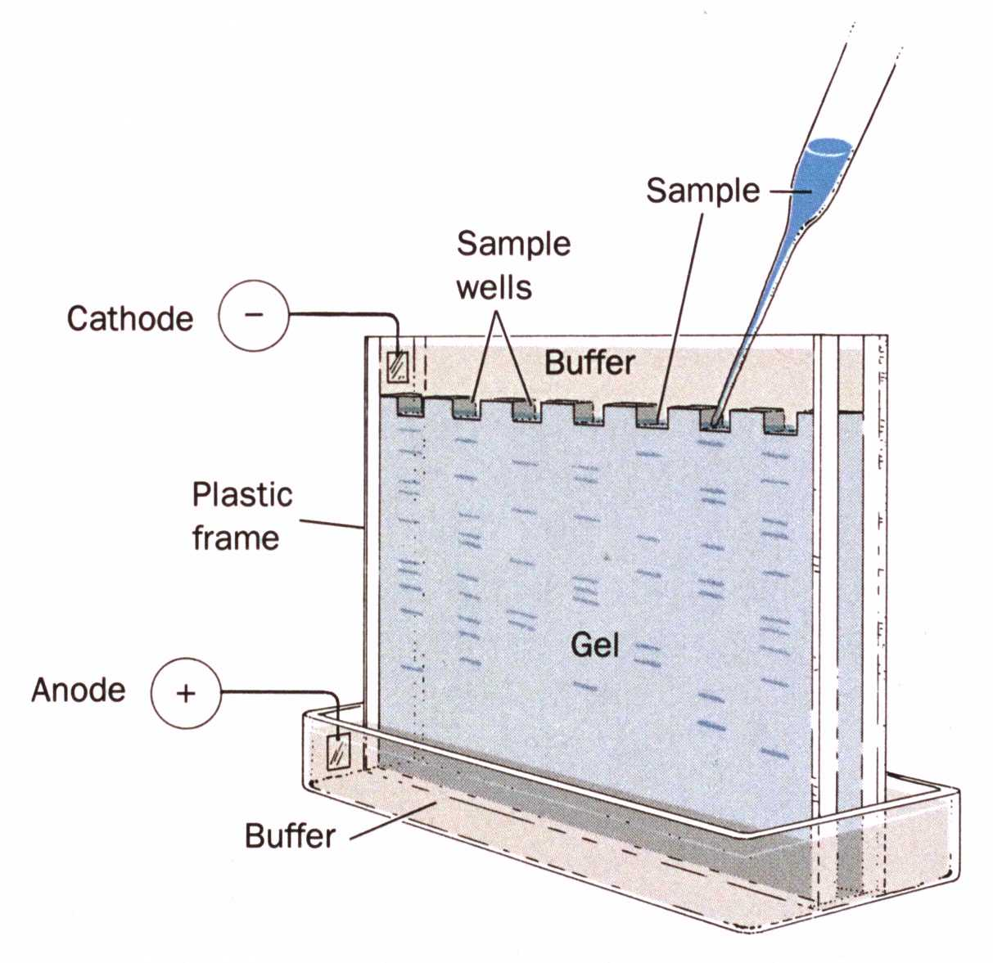

Iso-electric point (IEP)

Proteins can be separated using pH. At their iso-electric point they have an overall neutral charge and precipitate out of solution. This is important for conformational folding in proteins and can be used as a defining value for proteins. It can be calculated using information on all of the amino acids acid/basic characteristics and their number in the protein or it can be determined using a gel set up with a pH gradient and measuring the pH that the protein migrates to.

**(d) Antibody techniques**

Antibodies are an essential part of the immune system, but have become a very important part of techniques that require specific recognition. They are widely used in the detection and identification of specific proteins. Using an antibody that is tagged with a fluorescent dye or attached to a reporter enzyme, which will produce a colour change when given the enzyme substrate, they can be used to identify the presence of a particular antigen.

Monoclonal Antibodies

What are monoclonal antibodies?

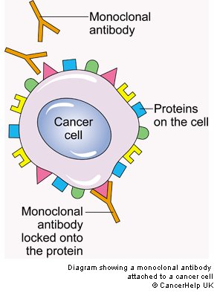

To make stocks of monoclonal antibodies requires the technique of somatic cell fusion.

A myeloma cell (an immortal cancer cell) and a B-lymphocyte (type of white blood cell that produces antibodies) are fused together to form a hybridoma - an immortal cell that produces antibodies to specific antigens.

The fusion is brought about using a particular fusion agent called polyethylene glycol (PEG).

Labelled antibodies are also used for immunohistological staining. What is this?

**(e) Microscopy**

What is the resolving power of a microscope?

Using light microscopy, the resolving power is limited by the wavelength of the light involved. This means a light microscope can be used to around x1500 magnification, allowing you to see down to ~0.2m. An advantage in using light (vs electron microscopy) is that the sample can be either living or dead, while in electron microscopy it must be dead. An electron microscope however has a resolving power down to ~0.2nm.

Bright field microscopy

Fluorescence microscopy

Cell counting and sorting

A basic use of microscopy is to sample the number of cells found in a particular area. This could be for microorganisms or from blood or tissue samples in multicellular organisms.

Technique 1 - Haemocytometers

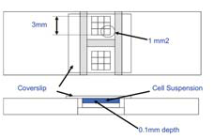

This is a special slide that was originally used in blood cell counting.

Technique 2 - Flow cytometry

Flow cytometry uses a system of light detection to count and sort cells.

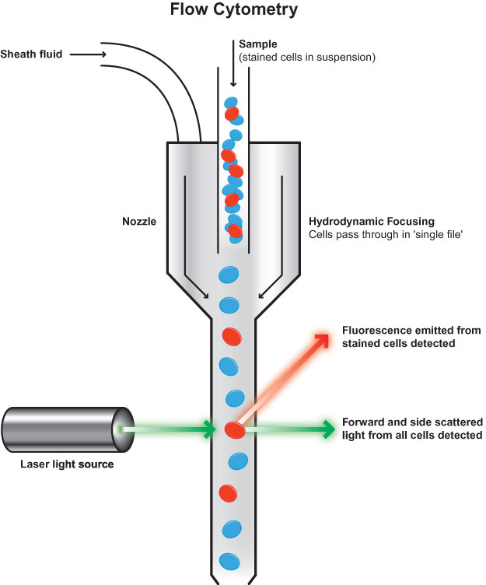

**(f) Cell culture and aseptic technique**

What is aseptic technique?

Cell culture

Cells grown in culture are much more easily manipulated and an essential part of cell and molecular biology. Some cells are fairly easy to grow in culture, but many have specific requirements.

1. Inoculum
2. Nutrient requirements
3. Complex Media

The health of a cell culture

Total cell count -

Viable cell count -

Lifetime of cell lines

Primary cell lines are limited in the number of divisions that they can go through before they die.

In human cells this is called the hayflick number which is linked to the number of telomere repeats found at the end of chromosomes.

Cancer cell lines (immortal cells) do not have this limit and so are often used for mammalian cell culture work.